Experiment No. 8

Tree Based Models and Ensemble LearningTechniques

Experiment No. 8.1

Classification Model using Decision Tree

1. Aim
To implement a classification model using Decision Tree and analyze its predictions and probability outputs.

2. Objectives
- To understand the concept of Decision Tree classification.
- To study how Decision Trees split data based on features.
- To build a Decision Tree model using training data.
- To predict class labels and probabilities.
- To visualize the Decision Tree structure.

3. Software Required
- Python 3.x
- Jupyter Notebook / Google Colab / Anaconda
- Scikit-learn Library
- Matplotlib Library

4. Introduction
Decision Tree is a supervised machine learning algorithm used for both classification and regression tasks.
It works by splitting the dataset into smaller subsets based on feature values, forming a tree-like structure.
Examples include:
Application | Prediction
Loan Approval | Approved / Rejected
Disease Diagnosis | Disease Type
Customer Segmentation | Category
Email Filtering | Spam / Not Spam
A Decision Tree consists of:
- Root Node (starting point)
- Decision Nodes (conditions)
- Leaf Nodes (final output)

5. Decision Tree Model
Decision Trees use measures like Gini Index or Entropy to determine the best split.
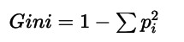
The model selects splits that minimize impurity and improve classification accuracy.

6. Steps in Building a Decision Tree Model
- Import required libraries
- Define dataset
- Train the Decision Tree model
- Predict class labels
- Predict probabilities
- Visualize the tree

7. Dataset Description
A simple dataset with two input features and a binary target variable is used.
Feature 1 | Feature 2 | Class
0 | 0 | 0
1 | 1 | 1
- Features are independent variables
- Class is the dependent variable

8. Dataset Characteristics
- Total number of records: 2
- Number of input features: 2
- Target variable: Binary class (0 or 1)
- Type of problem: Classification

9. Learning Objective
The model learns decision rules from input features to classify new data points and estimate class probabilities.

10. Program
from sklearn import tree
x=[0,0],[1,1]
y=[0,1]
model=tree.DecisionTreeClassifier()
model=model.fit(x,y)
model.predict([[2,2]])
model.predict_proba([[2,2]])
model.predict([[2,2]])
model.predict_proba([[2,2]])
tree.plot_tree(model)

11. Output
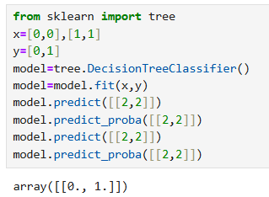
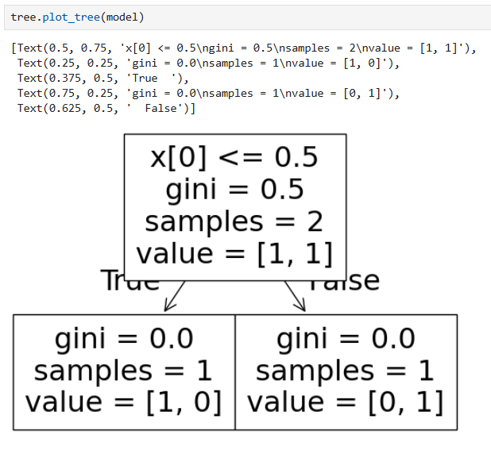

12. Graph Interpretation
- The root node represents the first decision condition.
- Branches represent possible outcomes of the condition.
- Leaf nodes represent final predicted classes.
- The tree classifies data based on feature values.

13. Result
The Decision Tree model was successfully implemented and correctly classified the input data while also providing prediction probabilities.

14. Conclusion
Decision Trees are simple yet powerful algorithms that model decision-making processes using a tree structure. They are easy to interpret and visualize, making them useful for classification tasks and understanding decision logic.

15. Viva Questions & Answers

1. What is a Decision Tree?
A Decision Tree is a supervised learning algorithm used for classification and regression.

2. What are the main parts of a Decision Tree?
Root node, decision nodes, branches, and leaf nodes.

3. What is classification?
Classification is predicting categories or classes from input data.

4. What is the Gini Index?
It is a measure of impurity used to select the best split in a Decision Tree.

5. What is entropy in Decision Trees?
Entropy measures randomness or impurity in data.

6. What are leaf nodes?
Leaf nodes represent final output classes.

7. What is overfitting in Decision Trees?
When the model memorizes training data and performs poorly on new data.

8. What is predict_proba()?
It returns probability values for each class.

9. What are advantages of Decision Trees?
Easy to understand, interpret, and visualize.

10. Where are Decision Trees used?
Healthcare, finance, customer analysis, spam detection, etc.

Experiment No. 8.2

Case Study: Decision Tree Classification using Play Tennis Dataset

1. Aim
To implement a Decision Tree classifier on a real-world dataset and visualize the decision-making process.

2. Objectives
- To understand the application of Decision Tree in real-world datasets.
- To preprocess categorical data using encoding techniques.
- To build a Decision Tree classification model.
- To visualize the tree structure for better interpretability.
- To analyze how decisions are made based on input features.

3. Software Required
- Python 3.x
- Jupyter Notebook / Google Colab / Anaconda
- Pandas Library
- Scikit-learn Library
- Matplotlib Library

4. Introduction
Decision Trees are widely used for classification problems because they are simple and easy to interpret.
In this case study, the Play Tennis dataset is used to predict whether a tennis match should be played based on weather conditions.
The model learns decision rules from features such as:
- Outlook
- Temperature
- Humidity
- Wind
The output predicts:
- Yes → Play Tennis
- No → Do Not Play Tennis

5. Decision Tree Model
Decision Trees split data using feature values to reduce impurity.
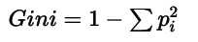
The feature with minimum impurity is selected for splitting.

6. Steps in Building the Model
- Import required libraries
- Load dataset
- Separate features and target variable
- Apply encoding techniques
- Train Decision Tree model
- Visualize the tree

7. Dataset Description
Attribute | Description
Outlook | Sunny, Overcast, Rain
Temperature | Hot, Mild, Cool
Humidity | High, Normal
Wind | Weak, Strong
PlayTennis | Yes / No
- All input features are categorical
- The target variable is PlayTennis

8. Dataset Characteristics
- Type of problem: Classification
- Input features: 4 categorical features
- Output variable: PlayTennis
- Dataset type: Real-world categorical dataset

9. Learning Objective
The model learns decision rules from weather conditions to determine whether tennis can be played.

10. Program
import pandas as pd
import matplotlib.pyplot as plt
from sklearn import tree
from sklearn.preprocessing import OneHotEncoder, LabelEncoder

df = pd.read_csv("PlayTennis.csv")

print(df)

X = df.iloc[:, 1:-1]
print(X.head())

x_col = X.columns

ohe = OneHotEncoder(drop='first', sparse_output=False)
X = ohe.fit_transform(X)

feature_names = ohe.get_feature_names_out(x_col)

le = LabelEncoder()
Y = df.iloc[:, -1]
Y = le.fit_transform(Y)

clf = tree.DecisionTreeClassifier(random_state=42)
clf = clf.fit(X, Y)

plt.figure(figsize=(14, 8))
tree.plot_tree(
clf,
feature_names=feature_names,
class_names=['No', 'Yes'],
filled=True
)
plt.show()

11. Output
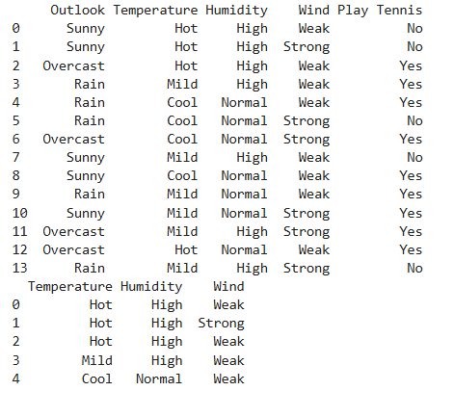

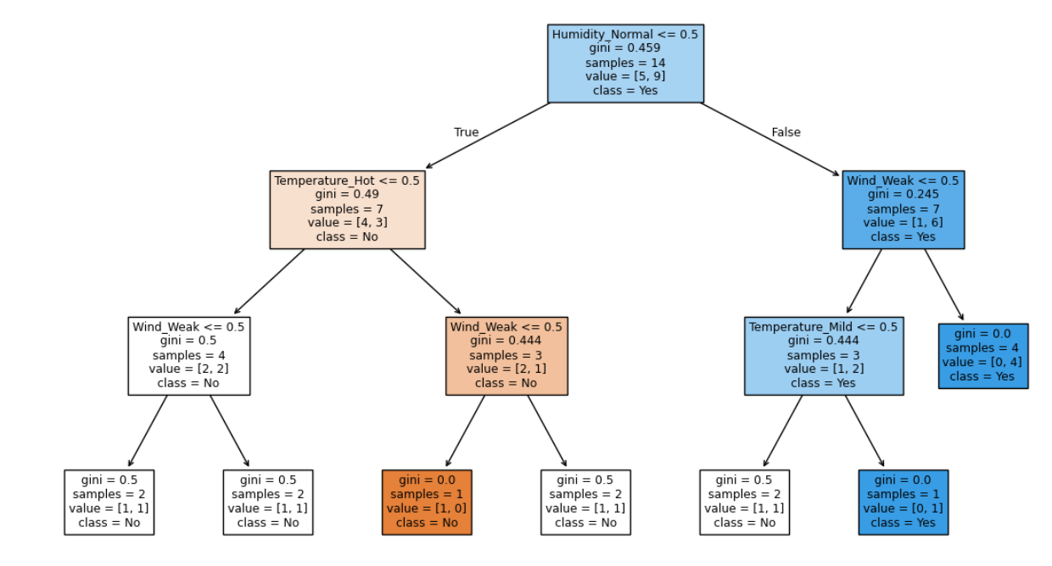

12. Graph Interpretation
- Root node represents the most important feature for classification.
- Branches represent decision conditions.
- Leaf nodes show the final prediction (Yes/No).
- The tree explains how weather conditions affect tennis decisions.

13. Result
The Decision Tree classifier was successfully implemented on the Play Tennis dataset and correctly generated decision rules based on weather conditions.

14. Conclusion
This case study demonstrates how Decision Trees effectively handle categorical data and generate interpretable decision rules. The visualization helps in understanding how different features influence the final decision.

15. Viva Questions & Answers

1. What is a Decision Tree classifier?
A supervised learning algorithm used for classification and regression tasks.

2. Why is encoding required in this dataset?
Because machine learning models require numerical input data.

3. What is One-Hot Encoding?
A technique that converts categorical values into binary columns.

4. What is Label Encoding?
A technique that converts categorical labels into numerical values.

5. What is Gini Index?
A measure of impurity used to select the best split.

6. How does a Decision Tree make decisions?
By splitting data using feature conditions.

7. What is overfitting in Decision Trees?
When the model learns training data too well and performs poorly on new data.

8. What is tree depth?
The maximum number of levels in a Decision Tree.

9. Why is visualization important in Decision Trees?
It helps understand the decision-making process clearly.

10. What are advantages of Decision Trees?
Easy to understand, interpret, and visualize.

Experiment No. 8.3

Hyperparameter Tuning of Decision Tree Classifier

1. Aim
To study and implement hyperparameter tuning techniques in Decision Tree Classifier to improve model performance and prevent overfitting.

2. Objectives
- To understand the concept of hyperparameters in machine learning.
- To study different hyperparameters of Decision Tree.
- To apply pre-pruning techniques to control tree growth.
- To compare model behavior with different parameter settings.
- To improve model generalization and avoid overfitting.

3. Software Required
- Python 3.x
- Jupyter Notebook / Google Colab / Anaconda
- Scikit-learn Library
- Matplotlib Library

4. Introduction
Decision Trees may overfit when they become very deep and learn unnecessary patterns from the training data.
Hyperparameter tuning helps control the complexity of the tree and improves prediction performance.
Two common approaches are:
- Pre-pruning (Stopping tree growth early)
- Post-pruning (Trimming the tree after training)
In this experiment, pre-pruning techniques are used.

5. Important Hyperparameters

1. Criterion
Determines how the quality of a split is measured.
- Gini Index
- Entropy (Information Gain)
Entropy formula:
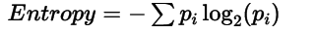

2. Max Depth
- Limits the maximum depth of the tree
- Prevents overfitting by restricting growth

3. Min Samples Split
- Minimum number of samples required to split a node
- Higher values create simpler trees

6. Steps in Hyperparameter Tuning
- Import required libraries
- Load or define dataset
- Train Decision Tree with default parameters
- Modify hyperparameters
- Compare results
- Analyze performance

7. Dataset Description
- A simple dataset is used to demonstrate hyperparameter tuning.
- The dataset contains input features and binary class labels.

8. Dataset Characteristics
- Type of problem: Classification
- Goal: Improve model generalization
- Approach: Pre-pruning

9. Learning Objective
To understand how tuning hyperparameters affects the structure, complexity, and performance of a Decision Tree model.

10. Program
# Import libraries
import pandas as pd
import matplotlib.pyplot as plt
from sklearn import tree
from sklearn.preprocessing import OneHotEncoder, LabelEncoder
from sklearn.metrics import accuracy_score

# Load dataset
df = pd.read_csv("PlayTennis.csv")

print("Dataset:")
print(df)

# Select features
X = df.iloc[:, 1:-1]

print("\nFeatures:")
print(X.head())

# Store column names
x_col = X.columns

# One-Hot Encoding
ohe = OneHotEncoder(drop='first', sparse_output=False)

X = ohe.fit_transform(X)

# Encoded feature names
feature_names = ohe.get_feature_names_out(x_col)

# Label Encoding for target variable
le = LabelEncoder()

Y = df.iloc[:, -1]

Y = le.fit_transform(Y)

# Default Decision Tree Model
default_clf = tree.DecisionTreeClassifier(random_state=42)

default_clf.fit(X, Y)

default_pred = default_clf.predict(X)

print("\nDefault Model Accuracy:",
accuracy_score(Y, default_pred))

# Hyperparameter Tuned Model
tuned_clf = tree.DecisionTreeClassifier(
criterion='entropy',
max_depth=3,
min_samples_split=2,
random_state=42
)

# Train tuned model
tuned_clf.fit(X, Y)

# Predictions
tuned_pred = tuned_clf.predict(X)

print("Tuned Model Accuracy:",
accuracy_score(Y, tuned_pred))

# Visualize tuned tree
plt.figure(figsize=(14, 8))

tree.plot_tree(
tuned_clf,
feature_names=feature_names,
class_names=['No', 'Yes'],
filled=True
)

plt.title("Hyperparameter Tuned Decision Tree - Play Tennis Dataset")

plt.show()

11. Output
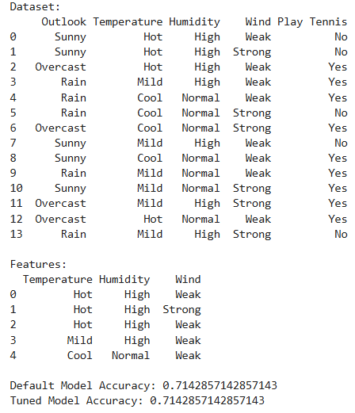
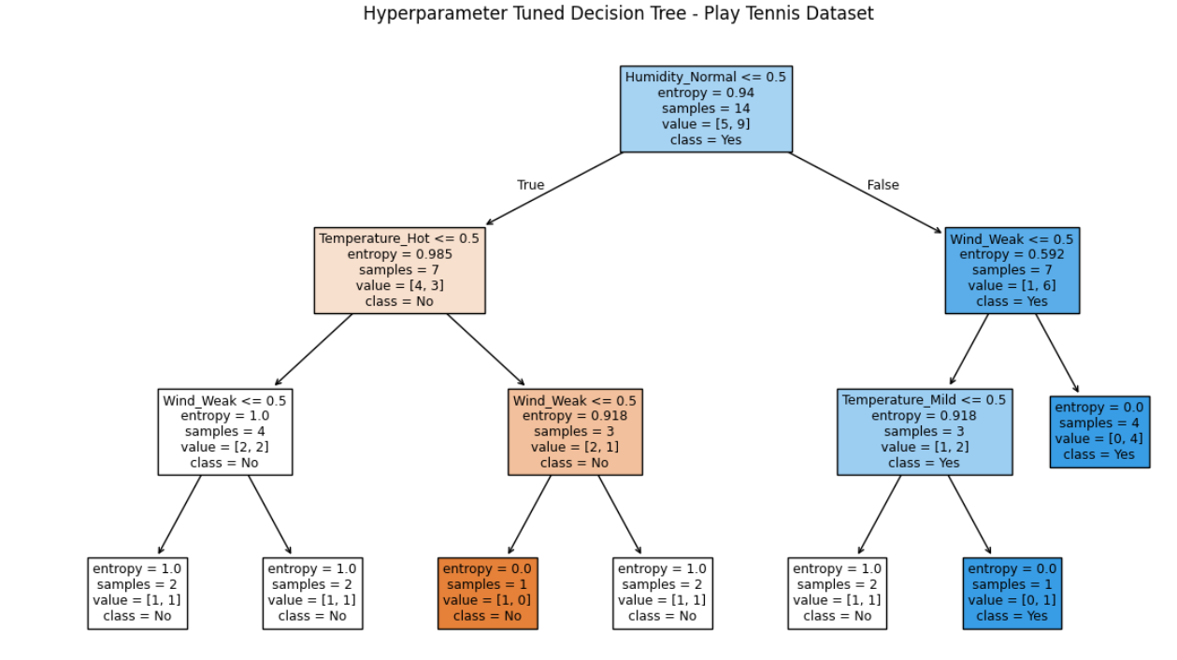
12. Graph Interpretation
Smaller tree depth creates a simpler and more generalized model.
Hyperparameters reduce unnecessary branches.
Tuned trees are easier to interpret and less prone to overfitting.

13. Result

The Decision Tree classifier was successfully tuned using hyperparameters such as criterion, max_depth, and min_samples_split, improving model generalization and reducing overfitting.

14. Conclusion
Hyperparameter tuning is essential for optimizing Decision Tree performance. Parameters like criterion, max_depth, and min_samples_split help balance bias and variance, leading to better model generalization.

15. Viva Questions & Answers
1. What are hyperparameters in machine learning?
Hyperparameters are parameters set before training the model.

2. What is overfitting in Decision Trees?
When the tree memorizes training data and performs poorly on new data.

3. What is pre-pruning?
Stopping tree growth early to reduce overfitting.

4. Difference between Gini and Entropy?
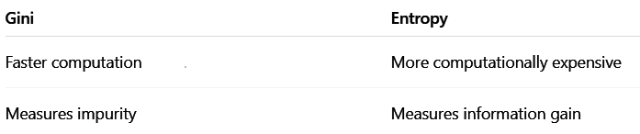

5. What is max_depth?
Maximum depth allowed for a Decision Tree.

6. What is min_samples_split?
Minimum samples required to split a node.

7. How does hyperparameter tuning improve performance?
It reduces overfitting and improves generalization.

8. What is bias-variance tradeoff?
The balance between underfitting and overfitting.

9. What happens if tree depth is too large?
The model may overfit the training data.

10. What is the role of entropy in Decision Trees?
Entropy helps select the best feature split based on information gain.

Experiment 8.4

Case Study: Random Forest Classification using Social Network Ads Dataset

1. Aim
To implement a Random Forest classifier on a real-world dataset and evaluate its performance using classification metrics.

2. Objectives
- To understand the concept of ensemble learning.
- To study the Random Forest algorithm.
- To build a classification model using multiple decision trees.
- To evaluate the model using confusion matrix and accuracy score.
- To visualize individual trees from the Random Forest.

3. Software Required
- Python 3.x
- Jupyter Notebook / Google Colab / Anaconda
- Pandas Library
- Scikit-learn Library
- Matplotlib Library

4. Introduction
Random Forest is an ensemble learning algorithm that combines multiple Decision Trees to improve accuracy and reduce overfitting. Instead of relying on a single tree, Random Forest constructs many trees and combines their predictions using majority voting for classification problems. It is widely used in marketing, healthcare, finance, and banking applications for prediction and classification tasks.

Applications of Random Forest
Application | Prediction
Marketing | Customer purchase prediction
Healthcare | Disease classification
Finance | Fraud detection
Banking | Loan approval

5. Random Forest Model
Random Forest works by:
- Creating multiple Decision Trees using random subsets of data
- Selecting random subsets of features for splitting
- Combining predictions using majority voting

Gini Index Formula
Gini=1−∑pi2Gini = 1 - \sum p_i^2Gini=1−∑pi2​
Where:
- pip_ipi​ = probability of each class

6. Steps in Building the Model
- Import required libraries
- Load dataset
- Select features and target variable
- Perform train-test split
- Train Random Forest model
- Predict test results
- Evaluate model performance
- Visualize one of the trees

7. Dataset Description
The dataset Social_Network_Ads.csv contains customer information used to predict purchasing behavior.
- Only numerical features are used.
- Purchased is the target variable.

8. Dataset Characteristics
Characteristic | Description
Type of Problem | Classification
Input Features | 2
Output Variable | Purchased
Dataset Type | Real-world dataset

9. Learning Objective
To understand how Random Forest improves prediction accuracy by combining multiple decision trees and reducing overfitting.

10. Program
import pandas as pd
from sklearn.model_selection import train_test_split
from sklearn.ensemble import RandomForestClassifier
from sklearn.metrics import confusion_matrix, accuracy_score
from sklearn.tree import plot_tree
import matplotlib.pyplot as plt
data = {
'Age':[19,35,26,27,19,27,32,25,35,26],

'EstimatedSalary':[19000,20000,43000,57000,
76000,58000,150000,33000,
65000,80000],

'Purchased':[0,0,0,1,0,1,1,0,1,1]
}

df = pd.DataFrame(data)

X = df[['Age','EstimatedSalary']]
y = df['Purchased']

X_train, X_test, y_train, y_test = train_test_split(
X, y, test_size=0.3, random_state=42)

model = RandomForestClassifier(
n_estimators=10,
random_state=42
)

model.fit(X_train, y_train)
y_pred = model.predict(X_test)
cm = confusion_matrix(y_test, y_pred)
accuracy = accuracy_score(y_test, y_pred)

print("Confusion Matrix:\n", cm)
print("Accuracy Score:", accuracy)

plt.figure(figsize=(10,6))

plot_tree(
model.estimators_[0],
feature_names=['Age','EstimatedSalary'],
class_names=['No','Yes'],
filled=True
)

plt.show()

Output:
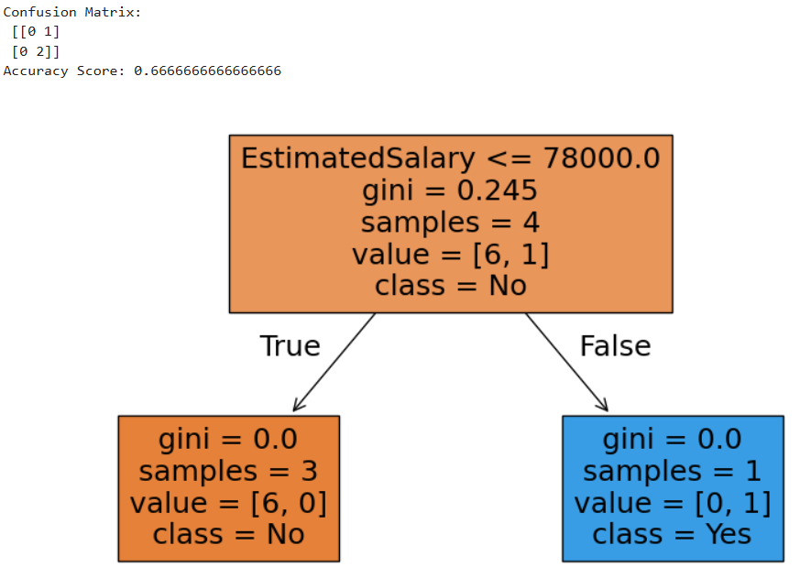

12. Conclusion
Random Forest is a powerful ensemble technique that improves prediction accuracy by combining multiple Decision Trees. It reduces overfitting and performs efficiently on real-world datasets, making it suitable for customer behavior prediction and classification problems.

13. Viva Questions and Answers

1. What is Random Forest?
Random Forest is an ensemble machine learning algorithm that combines multiple Decision Trees. Final prediction is based on majority voting.

2. What is ensemble learning?
Ensemble learning combines multiple models to improve accuracy and stability.

3. How does Random Forest reduce overfitting?
It trains many trees on random subsets of data and combines their predictions, reducing variance and overfitting.

4. What is bagging?
Bagging means Bootstrap Aggregating, where different datasets are created using sampling and each model is trained independently.

5. What is the role of n_estimators?
It defines the number of trees in the forest. More trees generally improve accuracy but increase computation time.

6. Why is feature randomness used?
Random feature selection makes trees different and reduces correlation between them, improving robustness.

7. What is Gini Index?
Gini Index measures node impurity. Lower values indicate better class separation.

8. Why is scaling not required in Random Forest?
Random Forest is tree-based and depends on feature splitting rather than distance calculations.

9. How is prediction made in Random Forest?
Each tree gives its own prediction, and final output is decided using majority voting.

10. Advantages of Random Forest?
- High accuracy and robustness
- Handles large datasets well
- Reduces overfitting compared to single decision trees

Experiment 8.5

Visualization of All Trees in Random Forest Model

1. Aim
To visualize all individual decision trees in a Random Forest model and understand the working of ensemble learning.

2. Objectives
- To understand the structure of Random Forest.
- To visualize multiple decision trees.
- To study variations among trees.
- To understand bagging and random feature selection.
- To analyze how ensemble learning improves prediction accuracy.

3. Software Required
- Python 3.x
- Jupyter Notebook / Google Colab / Anaconda
- Scikit-learn Library
- Matplotlib Library
- Pandas Library

4. Introduction
Random Forest is an ensemble learning algorithm that combines multiple Decision Trees to improve prediction accuracy and reduce overfitting.
Each tree in the forest is trained on randomly selected subsets of data and features. Due to this randomness, every tree becomes slightly different from the others.
Visualizing all trees helps in:
- Understanding decision-making processes
- Observing differences among trees
- Learning ensemble learning concepts
- Understanding randomness in machine learning

5. Theory

Random Forest
Random Forest is a supervised machine learning algorithm used for:
- Classification
- Regression
It works by combining predictions from multiple decision trees.

Main Concepts
- Bagging (Bootstrap Aggregation)
Random samples are selected from the dataset with replacement.
- Random Feature Selection
Random subsets of features are selected at each split.
- Majority Voting
Final prediction is based on the majority vote of all trees.

Gini Index Formula
The impurity of a node is calculated using:
Gini=1−∑pi2Gini = 1 - \sum p_i^2Gini=1−∑pi2​
Where:
- pip_ipi​ = probability of class iii
Lower Gini value indicates better purity.

6. Steps for Visualization
- Create dataset
- Split dataset into training and testing sets
- Train Random Forest model
- Access all trees using estimators_
- Visualize each tree using plot_tree()
- Analyze tree variations

7. Dataset Description
The dataset contains:
- Age of customer
- Estimated Salary
- Purchase status
Feature | Description
Age | Age of customer
EstimatedSalary | Salary of customer
Purchased | Yes/No

8. Dataset Characteristics
- Type of problem: Classification
- Number of trees: 10
- Model type: Ensemble Learning Model

9. Learning Objective
To understand how multiple decision trees contribute to final prediction and how diversity among trees improves overall model performance.

10. Program
import pandas as pd
import matplotlib.pyplot as plt
from sklearn.ensemble import RandomForestClassifier
from sklearn.tree import plot_tree
from sklearn.model_selection import train_test_split

data = {
'Age':[19,35,26,27,19,27,32,25,35,26],
'EstimatedSalary':[19000,20000,43000,57000,76000,
58000,150000,33000,65000,80000],
'Purchased':[0,0,0,1,0,1,1,0,1,1]
}

df = pd.DataFrame(data)

X = df[['Age','EstimatedSalary']]
y = df['Purchased']

X_train, X_test, y_train, y_test = train_test_split(
X, y, test_size=0.3, random_state=42)
rf_model = RandomForestClassifier(
n_estimators=10,
random_state=42
)

rf_model.fit(X_train, y_train)
for i, tree in enumerate(rf_model.estimators_):

plt.figure(figsize=(10,6))

plot_tree(
tree,
feature_names=['Age','EstimatedSalary'],
class_names=['No','Yes'],
filled=True
)

plt.title(f"Decision Tree {i+1}")
plt.show()

Output:
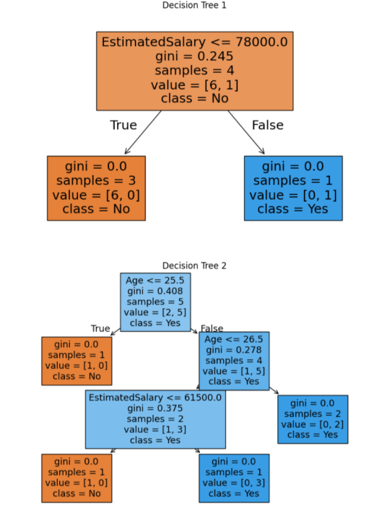
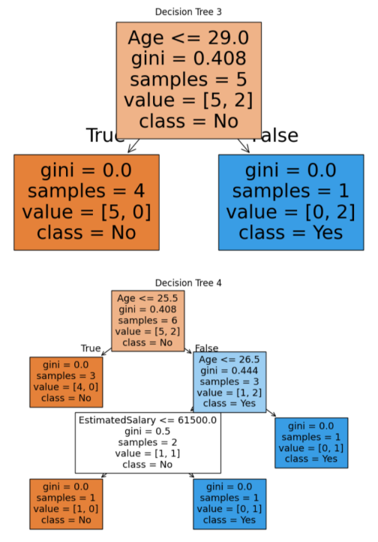
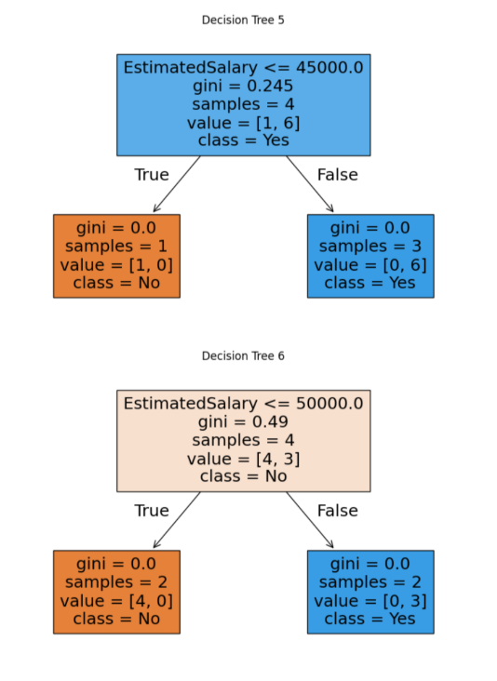
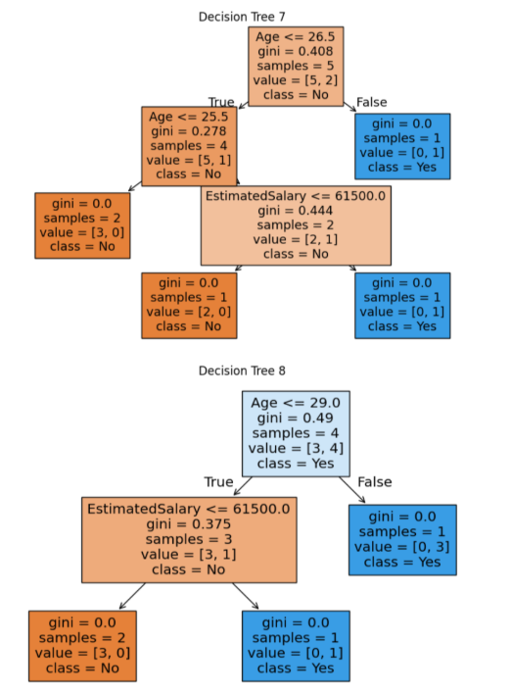
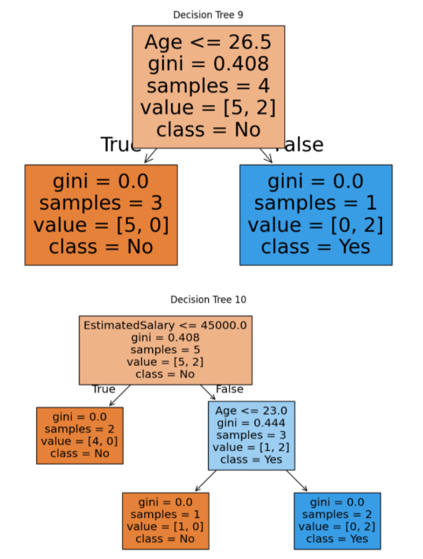

12. Conclusion
This experiment demonstrates that Random Forest consists of multiple diverse Decision Trees. Each tree contributes to the final prediction, and their combined prediction improves accuracy while reducing overfitting compared to a single Decision Tree.

13. Viva Questions

1. What is Random Forest?
Random Forest is an ensemble learning algorithm that combines multiple decision trees to improve prediction accuracy.

2. What is the role of estimators_?
estimators_ stores all trained decision trees of the Random Forest model.

3. Why are trees different in Random Forest?
Each tree is trained using random samples and random feature selection.

4. What is bagging?
Bagging means Bootstrap Aggregation, where random samples are selected with replacement.

5. What is feature randomness?
Random subsets of features are selected during splitting to create diversity.

6. How does Random Forest improve accuracy?
Predictions from multiple trees are combined using majority voting.

7. Why is visualization useful?
Visualization helps understand decision-making and tree structures.

8. What is ensemble learning?
Ensemble learning combines multiple models to improve performance.

9. How is final prediction made?
Final prediction is made using majority voting among all trees.

10. Advantages of Random Forest over Decision Tree?
- Higher accuracy
- Reduced overfitting
- Better generalization
- Handles large datasets efficiently

Experiment 8.6

Case Study: AdaBoost Classification using Decision Stumps

1. Aim
To implement the AdaBoost (Adaptive Boosting) algorithm using Decision Stumps and evaluate its performance on a real-world dataset.

2. Objectives
- To understand the concept of boosting in ensemble learning.
- To study the AdaBoost algorithm.
- To implement AdaBoost using weak learners (Decision Stumps).
- To evaluate model performance using accuracy and confusion matrix.
- To visualize individual weak learners in the ensemble.

3. Software Required
- Python 3.x
- Jupyter Notebook / Google Colab / Anaconda
- Pandas Library
- Scikit-learn Library
- Matplotlib Library

4. Introduction
AdaBoost (Adaptive Boosting) is an ensemble learning technique that combines multiple weak learners to form a strong classifier.
Unlike Random Forest, which builds trees independently, AdaBoost builds models sequentially where:
- Each new model focuses on correcting errors made by previous models
- Misclassified samples receive higher importance
- Weak learners gradually improve overall prediction accuracy

Applications Include:
Application | Prediction
Marketing | Customer purchase prediction
Finance | Fraud detection
Healthcare | Disease prediction
Email Filtering | Spam / Not Spam

5. AdaBoost Model
AdaBoost combines weak learners using weighted voting.
Each learner contributes based on its performance, and the final prediction is obtained by combining weighted outputs of all learners.

6. Steps in Building the Model
- Import required libraries
- Load dataset
- Select features and target variable
- Perform train-test split
- Define base learner (Decision Stump)
- Train AdaBoost model
- Predict test results
- Evaluate performance
- Visualize weak learners

7. Dataset Description
The dataset Social_Network_Ads.csv is used for predicting customer purchase behavior.
- Only numerical features are used.
- Purchased is the target variable.

8. Dataset Characteristics
- Type of problem: Classification
- Input features: 2
- Output variable: Purchased
- Model type: Ensemble (Boosting)

9. Learning Objective
To understand how AdaBoost improves classification performance by sequentially correcting errors using weak learners.

10. Program
import pandas as pd
import matplotlib.pyplot as plt
from sklearn.model_selection import train_test_split
from sklearn.tree import DecisionTreeClassifier, plot_tree
from sklearn.ensemble import AdaBoostClassifier
from sklearn.metrics import accuracy_score, confusion_matrix

data = {
'Age':[19,35,26,27,19,27,32,25,35,26],
'EstimatedSalary':[19000,20000,43000,57000,76000,
58000,150000,33000,65000,80000],
'Purchased':[0,0,0,1,0,1,1,0,1,1]
}

df = pd.DataFrame(data)

X = df[['Age','EstimatedSalary']]
y = df['Purchased']

X_train, X_test, y_train, y_test = train_test_split(
X, y, test_size=0.3, random_state=42)

stump = DecisionTreeClassifier(max_depth=1)

ada_model = AdaBoostClassifier(
estimator=stump,
n_estimators=10,
learning_rate=1,
random_state=42
)

ada_model.fit(X_train, y_train)
y_pred = ada_model.predict(X_test)

# Evaluation
print("Accuracy:", accuracy_score(y_test, y_pred))
print("Confusion Matrix:\n", confusion_matrix(y_test, y_pred))
for i, tree in enumerate(ada_model.estimators_):
plt.figure(figsize=(8,5))

plot_tree(
tree,
feature_names=['Age','EstimatedSalary'],
class_names=['No','Yes'],
filled=True
)

plt.title(f"Weak Learner {i+1}")
plt.show()

Output:
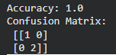
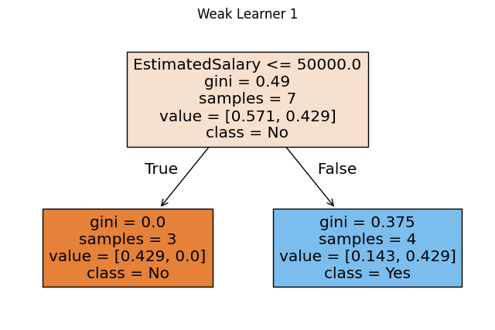
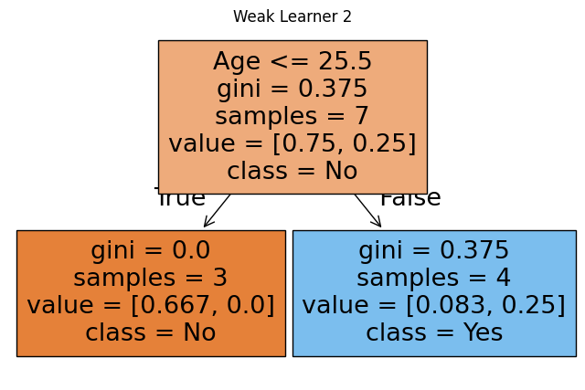
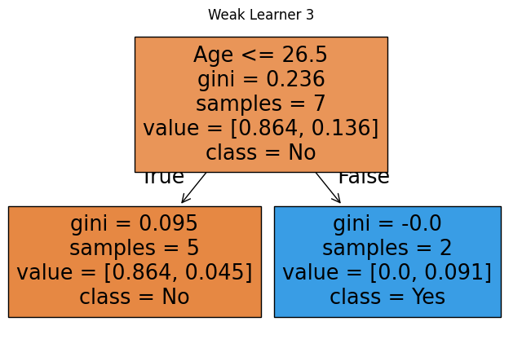
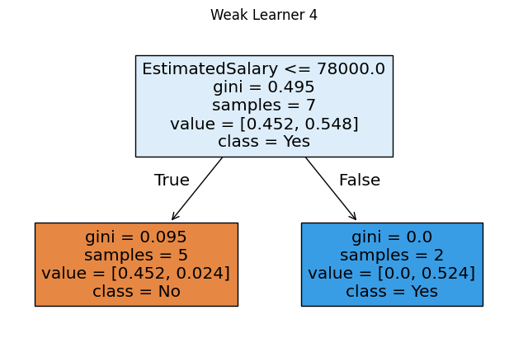
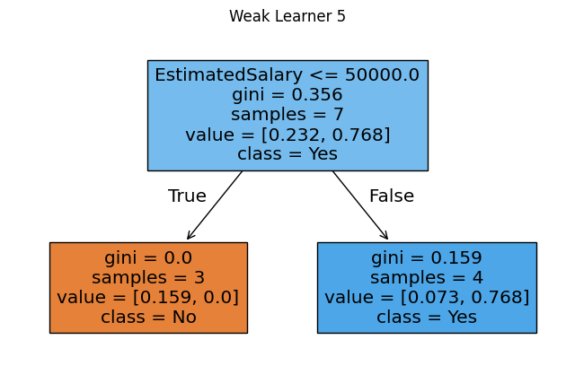
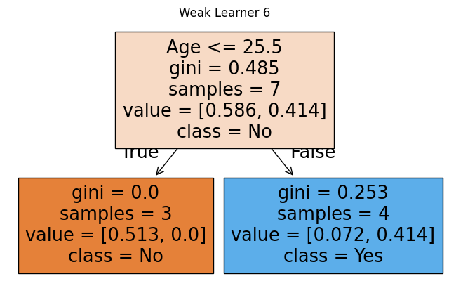
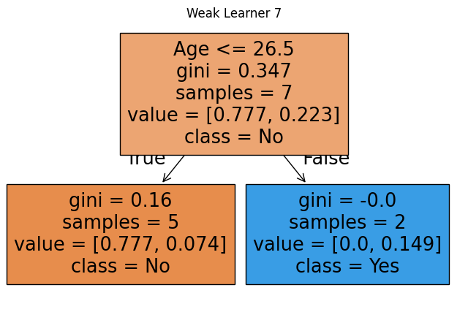
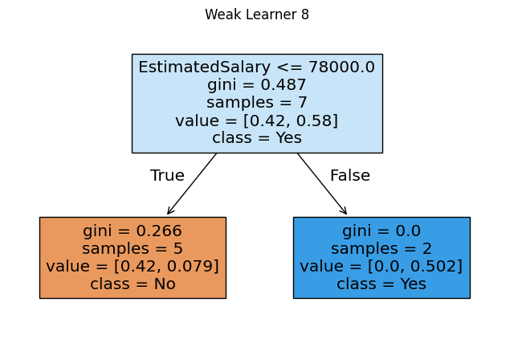
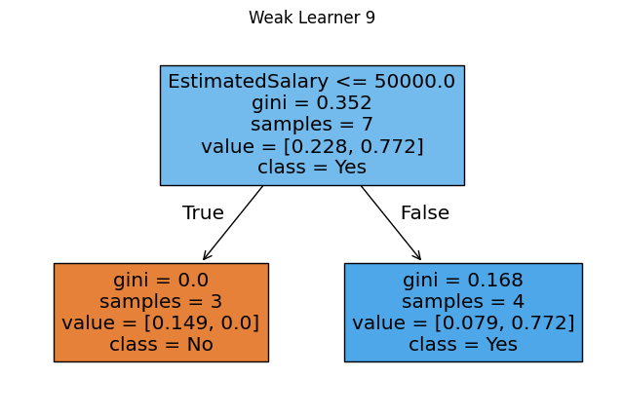
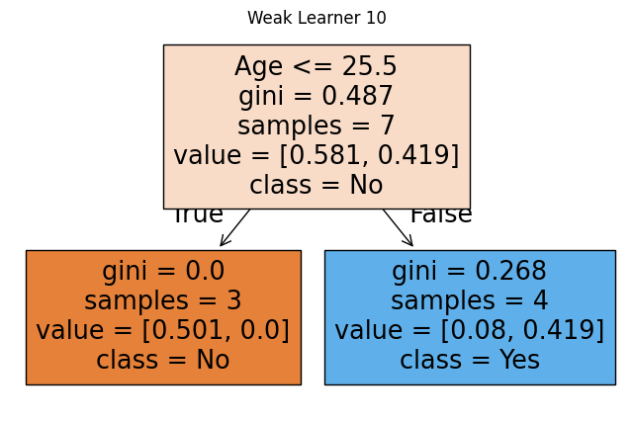

12. Result
The AdaBoost model was successfully implemented and achieved improved classification accuracy by combining multiple weak learners.
The confusion matrix shows effective classification, and visualization demonstrates how each weak learner contributes to the final strong model.

13. Conclusion
AdaBoost is a powerful boosting technique that improves model performance by focusing on difficult-to-classify samples. By sequentially combining weak learners, it creates a strong classifier suitable for real-world applications such as customer behavior prediction and fraud detection.

14. Viva Questions

1. What is AdaBoost?
AdaBoost is an ensemble boosting algorithm.
It combines multiple weak learners sequentially and creates a strong classifier from simple models.

2. What is boosting in machine learning?
Boosting trains models sequentially.
Each model corrects previous errors and improves overall prediction accuracy.

3. What is a weak learner?
A weak learner performs slightly better than random guessing.
It has low complexity.
Example: Decision Stump.

4. What is a Decision Stump?
A Decision Stump is a one-level Decision Tree.
It contains only one split and is used as a weak learner in AdaBoost.

5. How does AdaBoost handle misclassified samples?
Incorrectly classified samples receive higher weights.
The next learner focuses more on them, improving model learning.

6. What is the role of learning_rate?
Learning rate controls the contribution of each learner.
A lower value slows the learning process and helps prevent overfitting.

7. What is n_estimators?
It defines the number of weak learners.
More estimators may improve performance but increase computation time.

8. How is AdaBoost different from Random Forest?
AdaBoost | Random Forest
Trains models sequentially | Trains trees independently
Focuses on correcting errors | Uses bagging technique
Gives weight to misclassified samples | Uses random sampling

9. What is ensemble learning?
Ensemble learning combines multiple models to improve prediction accuracy and stability.
Examples: Random Forest and AdaBoost.

10. Advantages of AdaBoost
- High accuracy with simple models
- Reduces bias and variance
- Works well for classification tasks

Experiment 8.7

Case Study: XGBoost Classification Implementation

1. Aim
To implement XGBoost classification on a real-world dataset and evaluate the model using multiple performance metrics.

2. Objectives
- To understand the concept of gradient boosting.
- To study the XGBoost algorithm.
- To build a classification model using boosting techniques.
- To evaluate the model using accuracy, precision, recall, and F1-score.
- To compare performance with other ensemble methods.

3. Software Required
- Python 3.x
- Jupyter Notebook / Google Colab / Anaconda
- Pandas Library
- Scikit-learn Library
- XGBoost Library

4. Introduction
XGBoost (Extreme Gradient Boosting) is an advanced ensemble learning algorithm based on boosting techniques. It combines multiple weak learners to create a strong predictive model. Unlike traditional boosting algorithms, XGBoost improves performance through gradient descent optimization, regularization techniques to prevent overfitting, parallel processing, and high prediction accuracy. It is widely used in machine learning competitions and real-world applications because of its efficiency and scalability.

Applications of XGBoost
- Marketing – Customer purchase prediction
- Finance – Credit risk analysis
- Healthcare – Disease prediction
- E-commerce – Recommendation systems

5. XGBoost Model
XGBoost builds decision trees sequentially. Each new tree attempts to correct the errors made by the previous trees.
The objective function contains:
- Loss Function → Measures prediction error
- Regularization Term → Controls model complexity
This helps improve model accuracy while reducing overfitting.

6. Steps in Building the Model
- Install and import required libraries
- Load the dataset
- Select input features and target variable
- Perform train-test split
- Train the XGBoost classifier
- Predict test results
- Evaluate the model using performance metrics

7. Dataset Description

Dataset Used:
Social_Network_Ads.csv
Attribute | Description
Age | Age of customer
EstimatedSalary | Salary of customer
Purchased | 0 = No, 1 = Yes
- Only numerical features are used.
- Purchased is the target variable.

8. Dataset Characteristics
- Type of Problem: Classification
- Input Features: 2
- Output Variable: Purchased
- Model Type: Boosting (Ensemble Learning)

9. Learning Objective
To understand how XGBoost improves prediction accuracy by sequentially correcting errors and optimizing performance using gradient boosting techniques.

10. Program
import pandas as pd
from sklearn.model_selection import train_test_split
from sklearn.metrics import accuracy_score, classification_report
from xgboost import XGBClassifier
dataset = pd.read_csv("Social_Network_Ads.csv")
X = dataset[['Age', 'EstimatedSalary']]
y = dataset['Purchased']
X_train, X_test, y_train, y_test = train_test_split(
X, y, test_size=0.25, random_state=0
)
model = XGBClassifier(
learning_rate=0.1,
n_estimators=100,
max_depth=3,
use_label_encoder=False,
eval_metric='logloss'
)
model.fit(X_train, y_train)
y_pred = model.predict(X_test)
print("Accuracy:", accuracy_score(y_test, y_pred))
print(classification_report(y_test, y_pred))

Output:
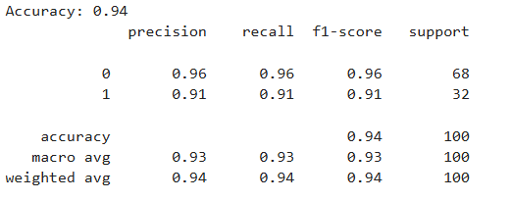

11. Conclusion
XGBoost is a powerful boosting algorithm that provides high prediction accuracy and efficient performance. By sequentially correcting errors and applying regularization techniques, it minimizes overfitting and improves model generalization. Therefore, XGBoost is highly suitable for real-world classification problems.

12. Viva Questions

1. What is XGBoost?
XGBoost is an optimized gradient boosting algorithm used for classification and regression tasks.

2. What is gradient boosting?
Gradient boosting is an ensemble technique where models are trained sequentially, and each new model corrects errors made by the previous model.

3. How is XGBoost different from AdaBoost?
XGBoost uses gradient optimization and regularization, while AdaBoost mainly focuses on adjusting weights of misclassified samples.

4. What is the role of learning_rate?
The learning rate controls how much each tree contributes to the final model.

5. What is n_estimators?
It represents the number of decision trees used in the model.

6. What is max_depth?
It controls the depth of each decision tree and helps prevent overfitting.

7. What is overfitting in boosting?
Overfitting occurs when the model learns the training data too well and performs poorly on unseen data.

8. What are precision, recall, and F1-score?
- Precision: Correct positive predictions ratio
- Recall: Ability to identify all positive cases
- F1-score: Harmonic mean of precision and recall

9. Why is XGBoost widely used?
Because it provides high accuracy, fast computation, and effective handling of complex datasets.

10. What are advantages of XGBoost?
- High performance
- Regularization support
- Handles missing data
- Parallel processing
- Prevents overfitting

